Question 1:

Created payload cybersecurity.

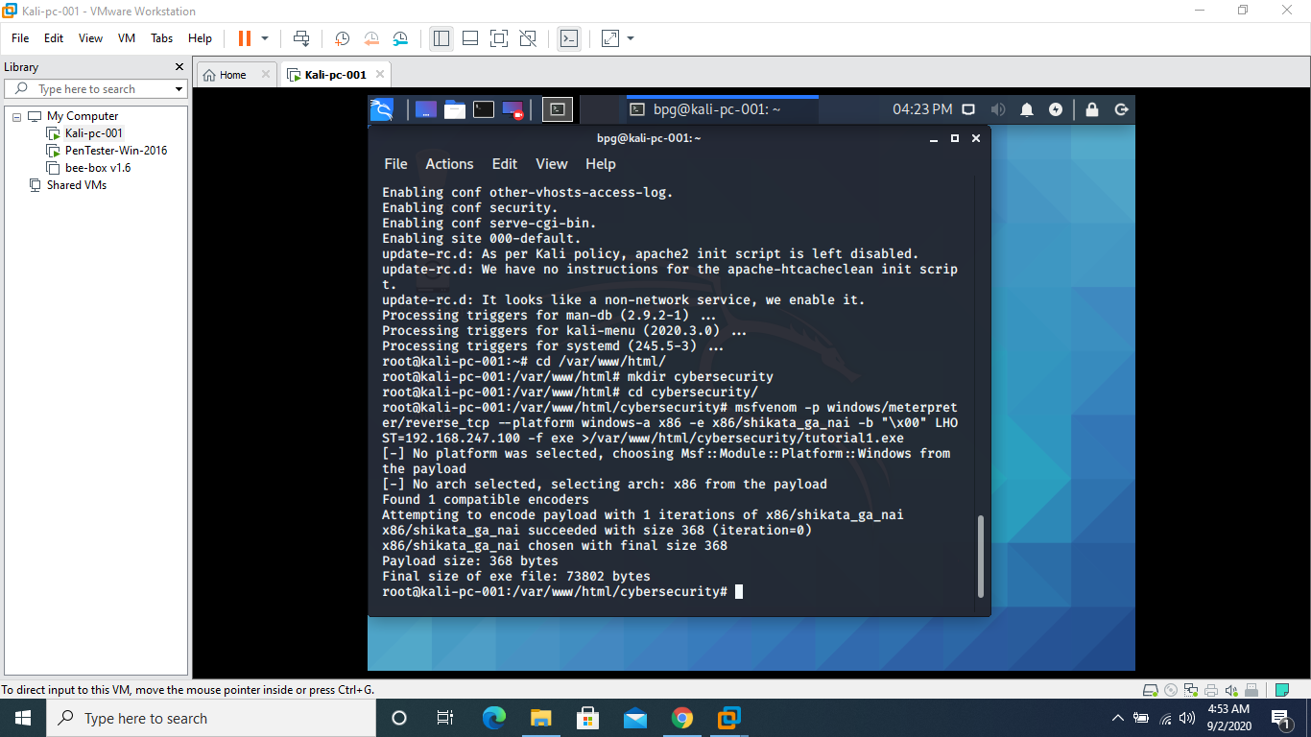

It is accessible from victim computer.

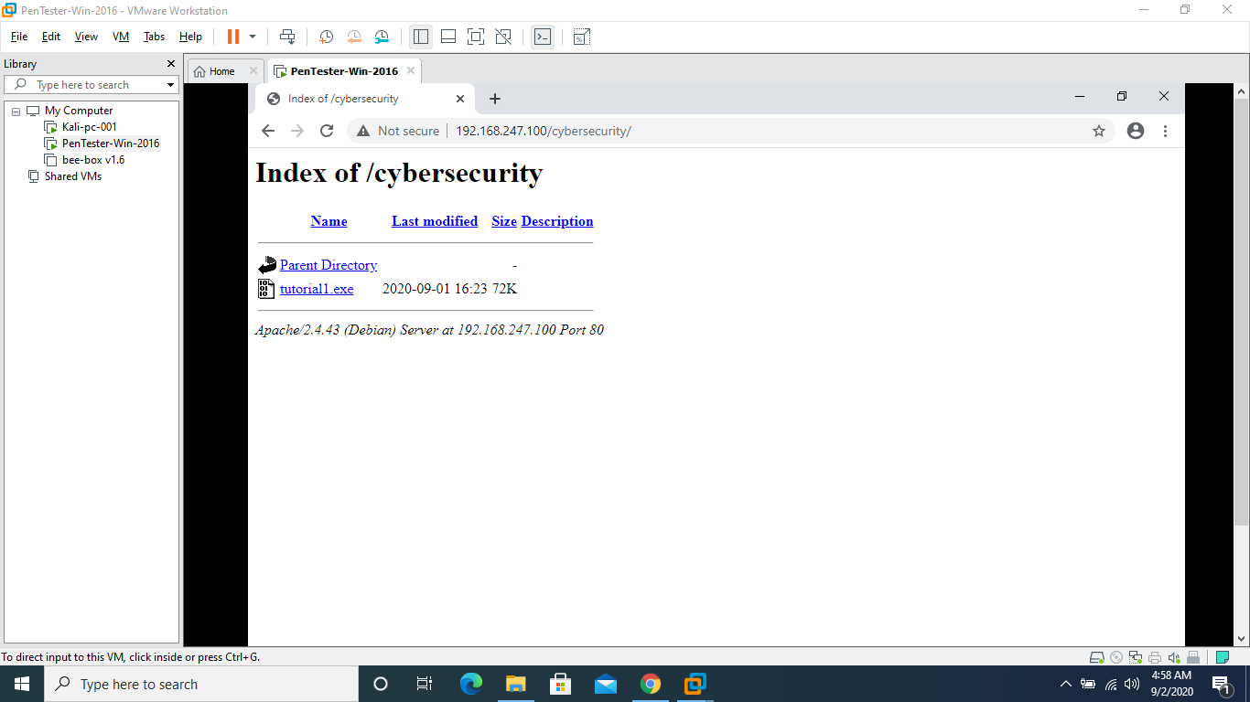

Payload is set and ready to exploit victim system

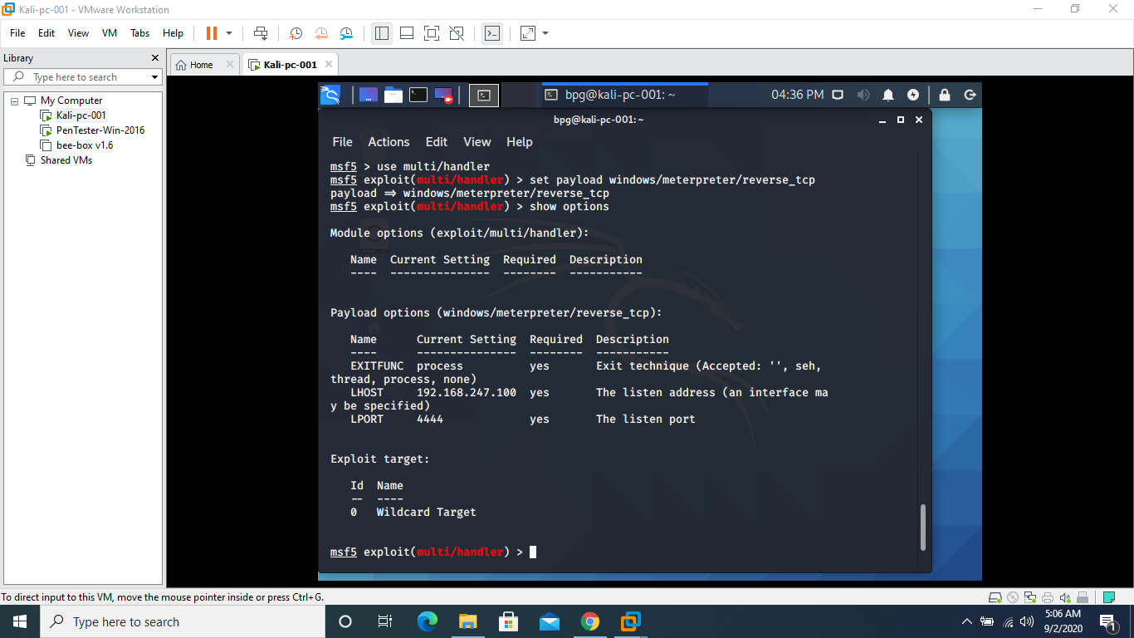

File a.txt is uploaded to victim machine and file b.txt is downloaded from it.

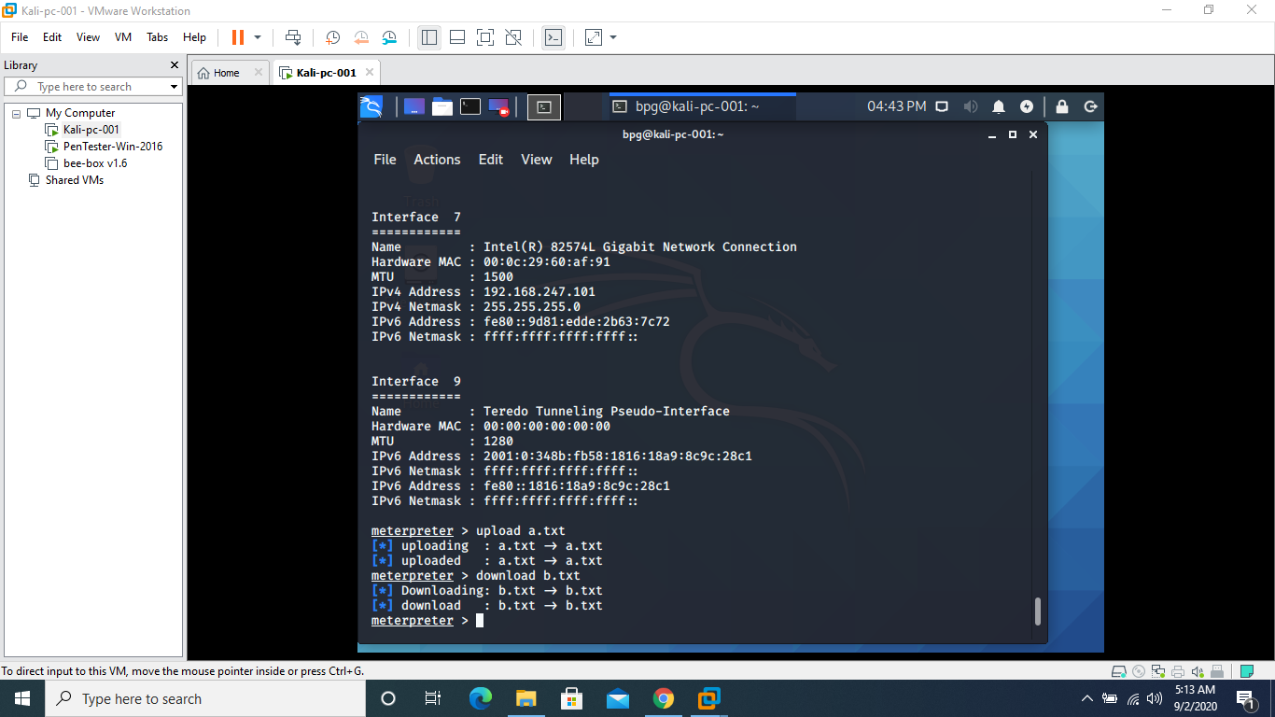

Screenshot of victim machine

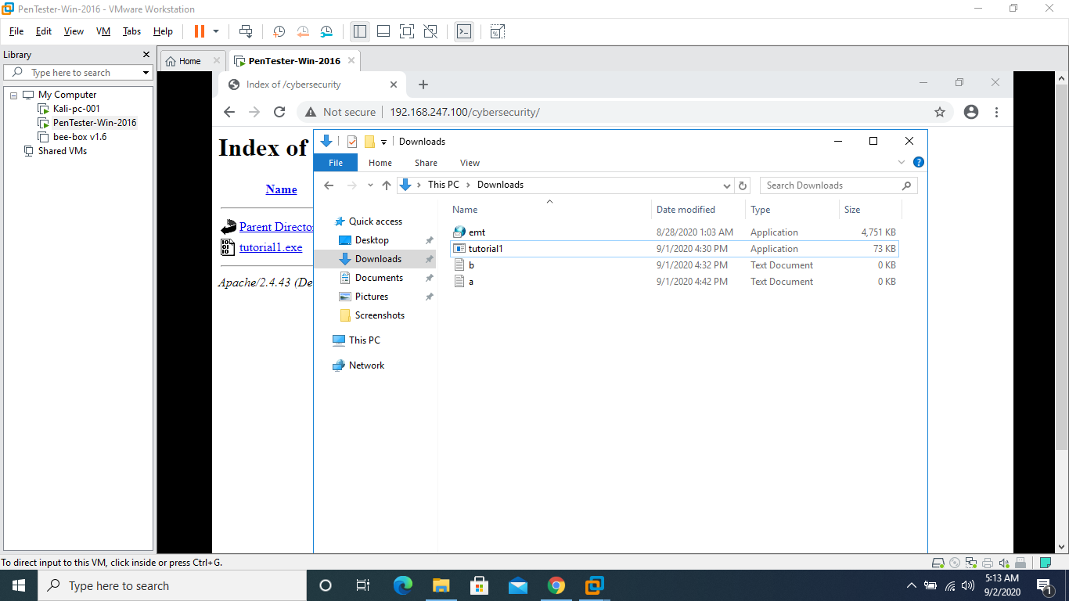

For question 2, I couldn’t create another pen test machine.